Discovering Climate Change - The Temperature Record

Matthew Coad

30 August 2018

## Introduction

A little while after Christmas, I was practicing data science in the [Pixel Bar](http://pixelbar.com.au/), a local tech bar. Using some of the sample data sets I had I was seeing if I could “replicate” some well-known principles. Like the squared relationship between a vehicles speed stopping distance, or the 11-year solar cycle from historical sunspot numbers.

Being a gaming bar, the Pixel was full of geeks as it usually is, and I overheard someone discussing having to share Christmas dinner with their climate-change denialism relatives.

One of the points that one of the relatives made was that they didn’t have the necessary skill or knowledge to interpret what was being handed down to them. That it in their case, accepting the theory of anthropogenic (which means human led environmental pollution) climate change, would be a matter of taking it on faith.

The geeks collectively admitted that they likewise lacked the necessary skill or knowledge to access or interpret the ideas being proposed by the scientific community. But lacking a better alternative they accepted it.

Which leads to an interesting question. Are my own beliefs on anthropogenic climate change based on any real knowledge or are they essentially just an *appeal to authority* of the scientific community?

And if I wanted to resolve this, could I, using the publicly available data and my growing data science skills, build a *justified* opinion in regard to anthropogenic climate change. And, to really show off, try to present my findings in an accessible way to bring my readers along with me.

I hope this article will be the first in a series that does precisely this. I plan to present the publicly available data sets. And then using them, see what I can find out about the various ideas regarding climate change.

## Turning up the heat globally

The global temperature has increased by 0.8 degrees Celsius. What does this mean, when on a typical day its 11c here in Melbourne, 27c in New York and -66c at Vostok Station in Antarctica?

What is the temperature of a *region*, given that the actual temperature is varying across that region?

In the context of climate change the temperatures provided are actually **temperature anomalies**. This is determined at individual temperature monitoring stations.

For each station we determine the average temperature at that station across a given period of time, called the **base line**. The temperature anomaly for a specific monitoring station is the difference between the temperature on any given day versus that base line temperature for that station.

A weather station at the bottom of a valley might record a very different set of temperatures as compared to one on top of a nearby mountain. By averaging the differences from the base-line at each station, you can get an idea of the temperature averages, and changes, across a region.

As well as determining the temperature anomaly for a geographic region, you can determine them across different time spans. And in the publicly available data sets, the temperature anomalies are given for a variety of regions and time-spans.

Examples include:

* the entire world per month.
* the northern hemisphere versus the southern hemisphere per year.

## Let’s see that slap-shot

So lets hit google, search for ‘global historical temperature’ and see what we can find.

The NASA Goddard Institute for Space Studies has a group called [GISTEMP](https://data.giss.nasa.gov/gistemp/) thats been pulling together temperature data for years. It looks great but only goes back to 1880, which is limited data if you’re looking at change-over-time. I’ll call this dataset the **GISTEMP**.

The website [Global Temperature Record](http://www.temperaturerecord.org/) has a number of data sets available, and we can go back to 0 AD. It has the ‘Highly variable Northern Hemisphere temperatures reconstructed from low and high-resolution proxy data.’ I’ll call this dataset **HVNHT**.

Let’s combine these datasets together and use it to plot global temperature from 0 AD to 2018 AD.

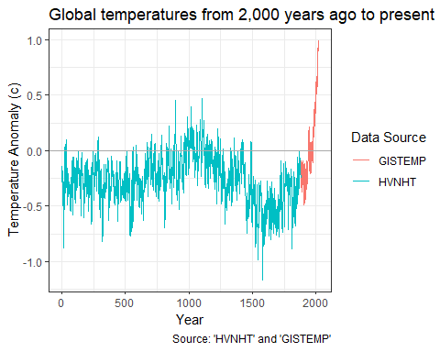

It’s an interesting result. It’s replication of the infamous hockey stick graph. (This term coined by climatologist Jerry D. Mahlman, to present the global or hemispherical mean temperature recorded in the past 500-2000 years.) It shows the temperature shuffling around for the last 2,000 years and *boom* it shoots off in the 20th century.

### 2000 years ago? Hang On, Did the Romans have thermometers?

No. It appears that none of the ancient civilisations had anything like a calibrated thermometer and there is no continuous written record of temperature that can be used.

The temperature records prior to 1880 (HVNHT) are reconstructions generated by examining sediment cores, ice cores, stalagmites and tree-rings. After 1880 (GISTEMP) there were enough instrument records around that we start using them instead.

In order to calibrate and check the accuracy of this sort of method, the researchers continued their HVHNT record till recent times and then cross checked it against records based on instrument readings when they became available.

## Breaking it down, 1880 style!

It’s 1880. Thomas Eidson helps back the very first edition of the journal “Science”. The Kelly gang are duking it out in Glenrowan. You can check out P.T. Barnum’s circus in downtown Bridgeport. And now there are enough temperature records going around that we can start using them instead of digging through sediment cores.

Lets focus in on that post 1880 GISTEMP data.

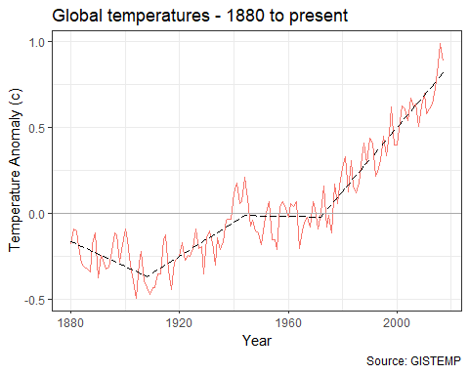

Okay we can see the temperature bouncing around a bit and then it really starts shooting up at around 1970.

I’ve unleashed a little bit of machine learning to put a trend line on the graph. I asked the machine to find a number of straight line segments that best fit the temperature vs year plot. The machine chose the 4 line segments shown above. It helps illustrate the trend in global temperatures. Keep note of that trend line, as it will appear in later graphs.

### North vs South

In 1880 the US Civil war ended just 15 years ago. However by this time we’ve now got enough documented temperature measurements from around the world that the guys at NASA reckon we can start looking at the temperature anomaly for different parts of the world. The GISTEMP data divides the earth up into zones based on ranges of latitude. Like the northern hemisphere versus the southern hemisphere, or the polar regions versus the tropics.

Lets compare the temperature changes in the Northern Hemisphere versus the Southern Hemisphere, along with that global trend line.

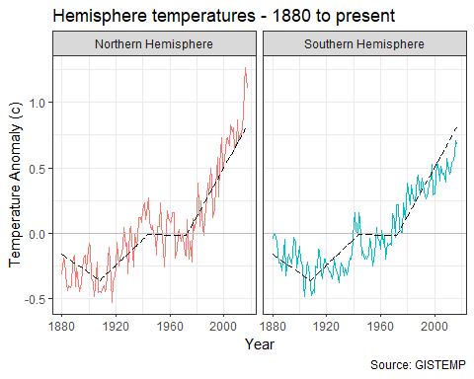

While the different hemispheres are pretty similar, there is a bit of variation, In particular there looks to be a notable deviation from 2000 onward, with the northern hemisphere heating up faster than the southern hemisphere.

A likely explanation for this is the differences in geography between the hemispheres. The southern hemisphere has a lot less landmass than the northern hemisphere. This can be explained as large bodies of water tend to dampen down and smooth out warming.

## Hypothesis Road-Test - It’s not actually warming!

In a hypothesis road-test, I take a commonly given hypothesis regarding climate change, and use the data I’ve got at hand to give it a bit of a shake down.

There isn’t a great deal we can do with just the temperature data on its own. But we can test something. And that is that the globe isn't actually warming at all!

Given what we’ve seen so far it sounds pretty crazy. However as always the devil is in the details. Specifically the idea is that the global warming trend stopped in 1998.

To see where the idea is coming from lets zoom in on that global temperature data from 1998 to 2013.

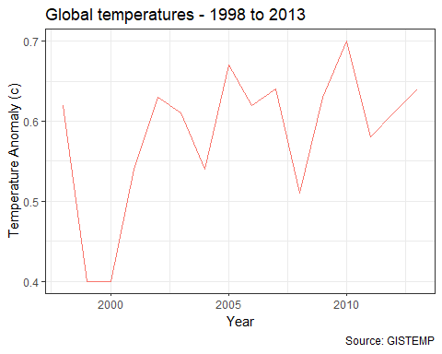

At a global level, for 15 years or so it looks like there wasn’t much warming.

But lets see what happens if we do that split into northern vs southern hemispheres again?

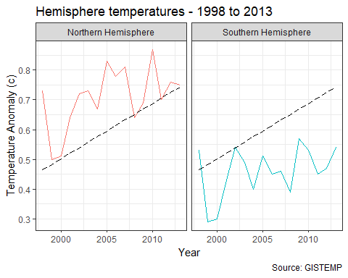

For good measure, I’ve left that global trend line in there as well.

From this plot you can see that the northern hemisphere warming continued unabated in accordance with the global trend. What happened is that the southern hemisphere had a pause in global warming.

Good news for the Southern Hemisphere? Well where I live in South East Australia that was actually a pretty crazy time, with the worst drought in recorded history, and it lasted for close to a decade. There were water restrictions for years on end and hey this is Australia, they know about drought. At least they thought they did. Climate change discussions loomed pretty large after that.

If you read up about it, there are theories attributing the cause to El Nino, sun brightness cycles being involved in that pause. Without some more data or information it is hard to say much more.

Note that all the region breakdowns show the same variations on a theme as the northern hemisphere versus the southern hemisphere.

### However that was then. What about now?

Well that pause was big news in 2013. Now lets let time advance to the present.

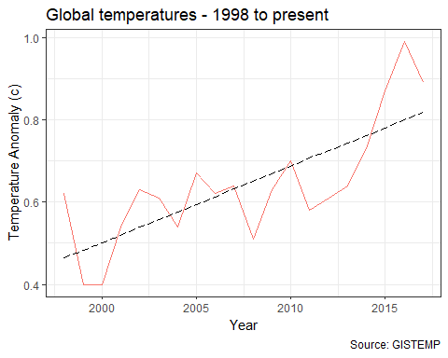

With the return of the trend line and a few more years of data it now looks like global warming never stopped. The temperature went up, chugged along flat for a bit while the southern oceans shuffled heat around for a decade or so. Then *bam!* It’s back!

**Road Test Conclusion:** Looked nice on the street fresh out of the car yard, but the shine faded over time. 2 Stars.

## Conclusion

It’s quite amazing the data you can just download these days. Its staggering the amount of work that must have gone into creating that temperature record. But both that record and the tools I used to analyze it were all available for free.

Using them we got to take a look at problem and so far, it looks like the problem is real. The earth does seem to be warming.

Not much maybe but it’s a start.

In the next article we’ll start to take a look at what is generally regarded as the main culprit, carbon dioxide.

## Data Sources

### GISTEMP

GISTEMP Team, 2018: GISS Surface Temperature Analysis (GISTEMP). NASA Goddard Institute for Space Studies. Dataset accessed 2018-09-03 at <https://data.giss.nasa.gov/gistemp/>.

### NVHNT

Northern Hemisphere temperatures reconstructed by statistically combining long-term fluctuations recorded by 11 low-resolution proxy series (lake and ocean sediments, ice cores, stalagmites) and short- term variations recorded by 7 tree-rings series. The reconstruction was calibrated by matching its mean and variance to the instrumental record of Northern Hemisphere annual mean temperature over the period of overlap (CE 1856-1979).

Credits: Moberg, A., D.M. Sonechkin, K. Holmgren, N.M. Datsenko, and W. Karlén. 2005. Highly variable Northern Hemisphere temperatures reconstructed from low- and high-resolution proxy data. Nature, Vol. 433, pp. 613-617.

Dataset accessed 2018-09-03 at <http://www.temperaturerecord.org/>.